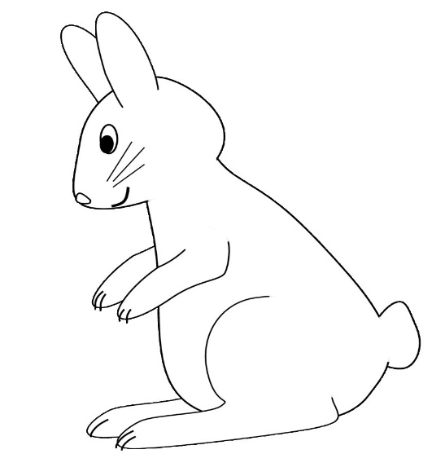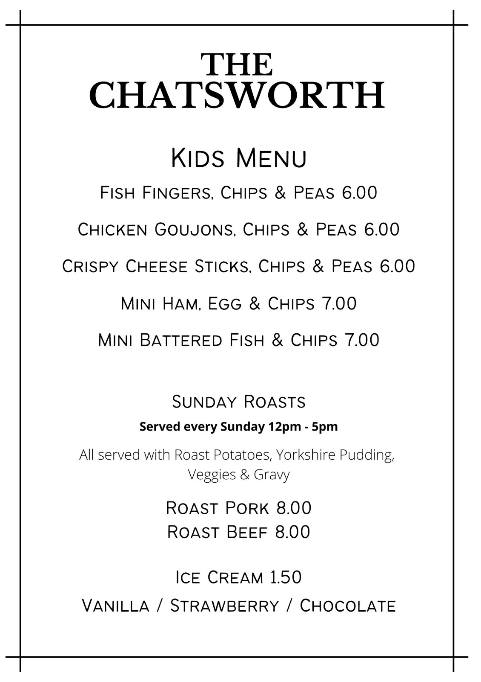

**F-Flowers**

**B-BALLOON**

**S-Spring**

**B-BALLOON**